Channel protections
Power modules are designed with multiple protection functions to avoid various unexpected conditions, for example output values exceeding the set limits which (if unchecked) could cause permanent damage to a connected device or the power module itself.

Clearing an activated protection mode, disabling protection modes or setting protection mode parameters may be accessed via Protections section on the Channel protection and settings page.  If any of enabled protections are tripped, for example an over-current protection, a popup message will appear and channel settings icon will be changed to the shield icon colored in red. | 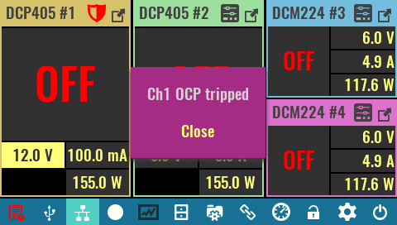
Clear protection  Use this option on the Protections and Settings page to clear all tripped protections, channel outputs can then be re-enabled as needed.  The status of active protections is not affected by this option. | 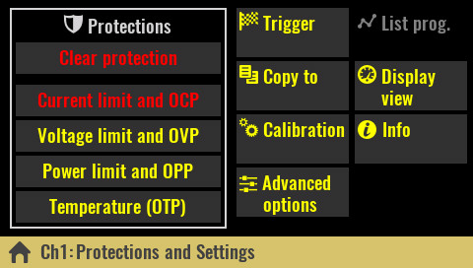
The same option can be used from the tripped protection settings page to clear related protection trip. | 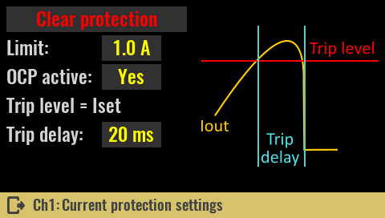
SCPI
OUTPut:PROTection:CLEar
CURRent:PROTection:STATe OFF
POWer:PROTection:STATe OFF
VOLTage:PROTection:STATe OFF
SYSTem:TEMPerature:PROTection:STATe OFF, <sensor>

Current limit and OCP  Limit  Defines the max. value of the output current that the user will be able to set. The initial value is max. current the module can source (e.g. 5 A for the DCP405 module).  Changing the limit will also affect graphical views (vertical bar, horizontal bar and YT views), if the display setting of the channel is set to Limit (see Display view section). For example, if the limit is set to 1 A, this value will become 100% of the scale instead of only 20% when the limit is at 5 A. | 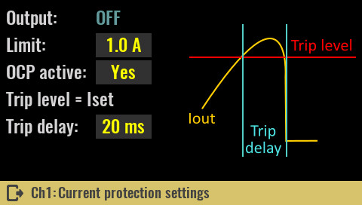
SCPI
CURRent:LIMit {<current>}

OCP active
The OCP (Over-Current Protection) is software protection that will activate when drawn current reaches the set value of the allowed output current. A protection mode trip will be recorded in the event log and the channel output will be turned off.

Use this option to turn OCP on or off. If OCP is off, if the output current reaches the set value (I_{set}) the channel will switch from CV to CC mode without turning off the channel output.

SCPI
CURRent:PROTection:STATe {<bool>}

Trip delay
If the OCP is enabled and the output current reaches the set value (I_{set}), an OCP trip will occur at the earliest after the set delay time expires.

SCPI
CURRent:PROTection:DELay {<time>}

Voltage limit and OVP  Limit  Defines the max. value of the output voltage that the user will be able to set. The initial value is max. voltage the module can source (e.g. 40 V for the DCP405 module).  SCPI  VOLTage:LIMit {<voltage>}  OVP active | 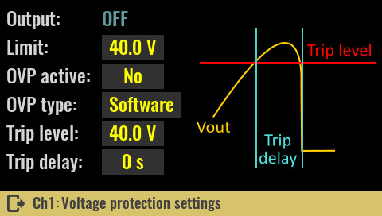
The OVP (Over-Voltage Protection) is software protection that will activate when output voltage reaches the programmed value. Protection trip will be recorded in the event log and the channel output will be turned off.

Turns OVP on or off. If OVP is off (which is default), when the output voltage reaches the set value (U_{set}) the channel will enter the CV mode (which is normal behavior if the connected load does not draw more current than the maximum set). Therefore, when activating OVP without load or with connected load that draws less than the set current, the channel will enter CV mode and the OVP will immediately trip. To avoid this the channel should be in CC mode prior to the output being turned on.

SCPI
VOLTage:PROTection:STATe {<bool>}

OVP type
Selection between software and hardware OVP is only possible with DCP405 modules.

SCPI
VOLTage:PROTection:TYPE SW

Trip level
The trip level value may be greater than or equal to the set voltage (U_{set}) and determines the value of the output voltage at which the OVP will trip. In case the set value of the output voltage increases, the trip level will automatically increase.
For example, if the trip level was set at 10 V while the output voltage was also at 10 V and its value increased to 12 V, the trip level value would also increase to 12 V. But, if the voltage drops to say 5 V, the trip level will remain unchanged.

Max. trip value is 0.05 V greater than max. output voltage (i.e. 40.05 V for DCP405 module).

SCPI
VOLTage:PROTection {<voltage>}

Trip delay
If the OVP is enabled and the output voltage reaches the set trip level, an OVP trip will occur at the earliest after the set delay time expires.

SCPI
VOLTage:PROTection:DELay {<time>}

Hardware OVP  The DCP405 module also contains hardware OVP that works on a slightly different principle. Unlike software OVP where it is possible to adjust the trip level, with this protection the trip level is automatically set at approximately 3% above the set voltage output. The response rate (ie trip delay) also cannot be changed, but the OVP circuit will respond as quickly as possible.  SCPI  VOLTage:PROTection:TYPE HW | 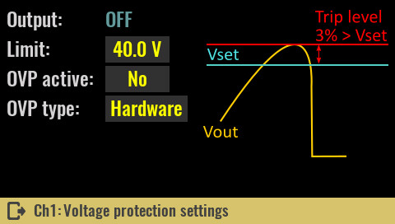

Power limit and OPP  Limit  Defines the max. value of the output power that the user will be able to set. The initial value is max. power the module can source (e.g. 155 W for the DCP405 module).  SCPI  POWer:LIMit {<power>}  OPP active | 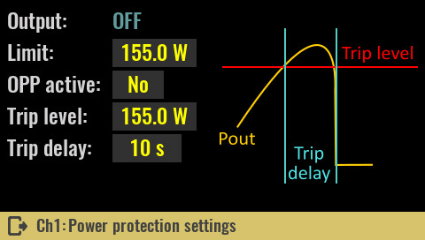
The OPP (Over-Power Protection) is software protection that will activate when output power reaches the programmed value. Protection trip will be recorded in the event log and the channel output will be turned off.

SCPI
POWer:PROTection:STATe {<bool>}

Trip level
The trip level value may be less than or equal to the set limit and determines the value of the output power at which the OPP will trip. When the power limit is set to a lower value, the trip level will also decrease.

SCPI
POWer:PROTection {<power>}

Trip delay
If the OPP is enabled and the output power reaches the set trip level, an OPP trip will occur at the earliest after the set delay time expires.

SCPI
POWer:PROTection:DELay {<time>}

Temperature (OTP)  OTP active  The OTP (Over-Temperature Protection) is software protection that will activate when the temperature measured on the channel’s temperature sensor is equal to or greater than the set trip level value for a duration of trip delay.  Protection trip will be recorded in the event log and the channel output will be turned off. | 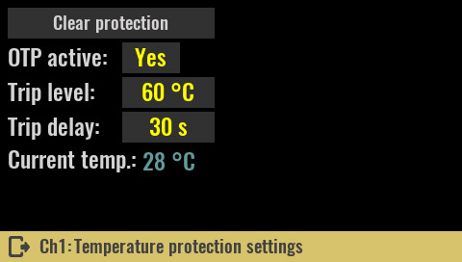
Dual channel modules like the DCM220 have two temperature sensors, one for each channel.

SCPI
SYSTem:TEMPerature:PROTection:STATe {<bool>} [, <sensor>]

Trip level
The trip level value may be less than or equal to the set limit and determines the value of the measured temperature at which the OTP will trip.

SCPI
SYSTem:TEMPerature:PROTection {<temperature>}, <sensor>]

Trip delay
If the OTP is enabled and the temperature reaches the set trip level, an OTP trip will occur at the earliest after the set delay time expires.

SCPI
SYSTem:TEMPerature:PROTection:DELay {<delay>}, <sensor>

